标题：Unveiling Ceremony of the Joint Research Center for Flexible Three-Dimensional Electronic Skin Technology
On January 15, 2026, the unveiling ceremony of the Joint Research Center for Flexible Three-Dimensional Electronic Skin Technology co-founded by Tsinghua University (School of Aerospace Engineering, SAE) and Jiangsu SDK New Materials Technology Co., Ltd. (hereinafter referred to as the "Joint Research Center") was held at Tsinghua University. Responding to the national "AI+" strategic deployment, this cooperation focuses on the technological R&D and industrial transformation of flexible three-dimensional electronic skin devices. Through university-enterprise collaboration, it will smooth the technology transformation chain and provide important impetus for the development of advanced artificial intelligence equipment.
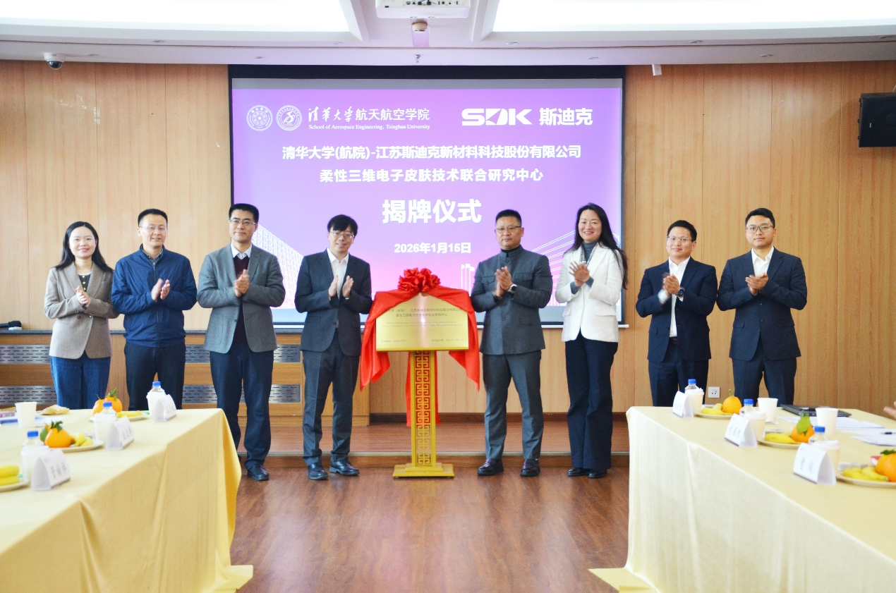
Zhang Yihui, Director of the Joint Research Center, and Jin Chuang, Chairman of Jiangsu SDK New Materials Technology Co., Ltd., jointly unveiled the plaque for the Joint Research Center. Cao Bingyang, Dean of the School of Aerospace Engineering, Yang Bi, Executive Vice President of Jiangsu SDK New Materials Technology Co., Ltd., Cao Chuang, R&D Director, and other guests witnessed the establishment of the Joint Research Center.
In his speech, Cao Bingyang stated that the School of Aerospace Engineering not only pursues "groundbreaking breakthroughs" in the field of aerospace but also strives to promote the industrialization of high and new technologies rooted in practical applications in key national economic pillar industries, important people's livelihood sectors, and basic national economic security fields, fulfilling its mission and responsibility of serving the country and the people. He expressed hope that with the Joint Research Center as the driving force, the school will steadily deepen its efforts in the field of electronic skin and achieve greater progress.
Jin Chuang noted in his speech that SDK has been deeply engaged in the functional film materials field for 20 years. This cooperation with Tsinghua University's School of Aerospace Engineering represents a mutual commitment between top scientific research wisdom and industrial practice strength. Targeting key technical bottlenecks in the electronic skin field, the two parties will explore low-cost mass production paths through collaborative research, enabling laboratory achievements to take root in practice and empowering the transformation and upgrading of intelligent manufacturing.
The Joint Research Center aims to build a collaborative platform for in-depth integration of industry, academia, and research. As a leading enterprise in the high-end functional film materials field, SDK has accumulated solid technical reserves, complemented by mature large-scale production capabilities, precision manufacturing expertise, and a stable supply chain system. It provides key technical support for electronic skin R&D in areas such as flexible substrate materials and precision coating processes, laying an efficient industrialization channel for scientific research achievements. Its industrial advantages form precise complementarity with Tsinghua University's (SAE) profound scientific research accumulation in flexible electronic technology, structural mechanics, and other fields, enabling innovative achievements to quickly connect with market applications.
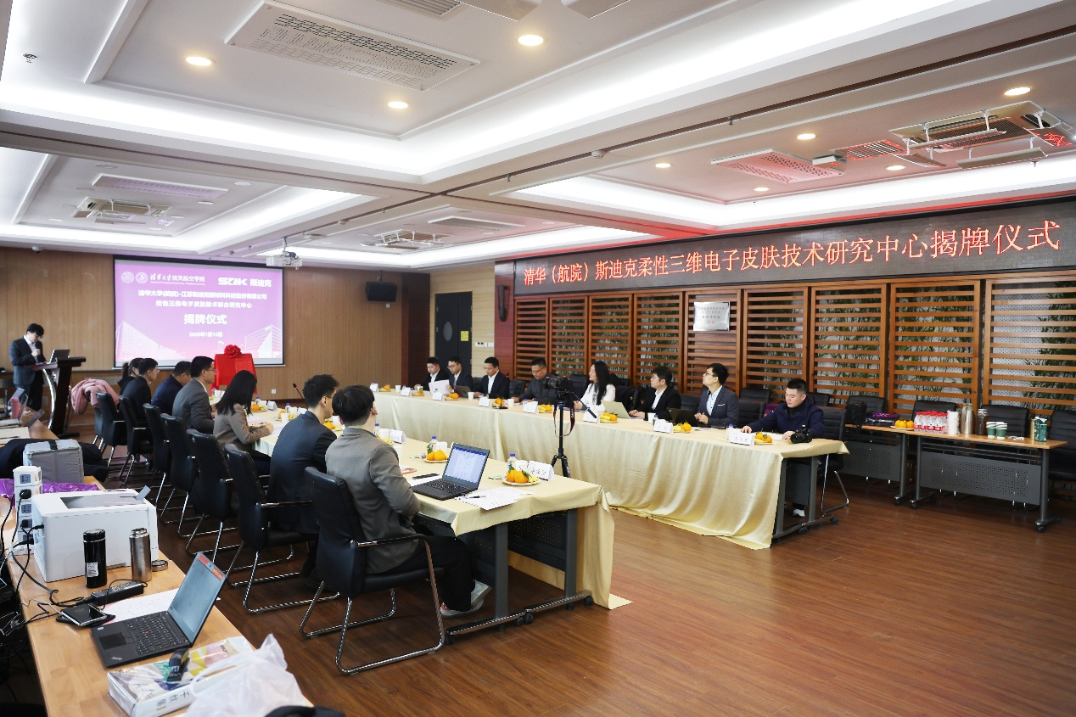
In the future, SDK will continue to deepen collaborative cooperation with Tsinghua University (School of Aerospace Engineering), deeply participate in key links of technology industrialization, promote the application of relevant technologies in fields such as industry and medical care, help enhance the overall competitiveness of China's flexible electronic sensing technology, and jointly contribute to the construction of an intelligent economy and an intelligent society.

